SWITCH AND ROUTER CONFIGURATION

Q1. Log in to Cisco Packet Tracer or any network simulation tool, add a switch, and create two VLANs named 'Sales' and 'Support' with VLAN IDs 10 and 20.
Ans.
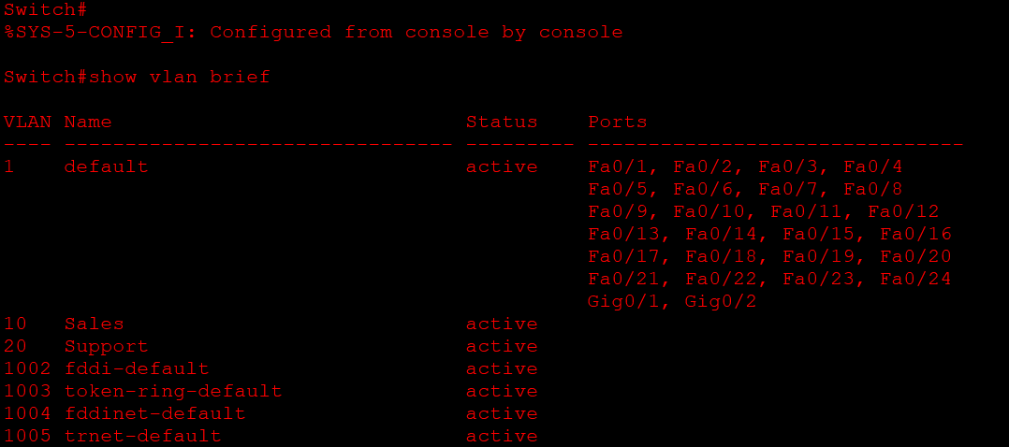
Q2. Assign three different switch ports to VLAN 10 (Sales) and two ports to VLAN 20 (Support), then verify the VLAN membership using the show VALN command. Hint: Use the interface range command to select multiple ports efficiently.
Ans.
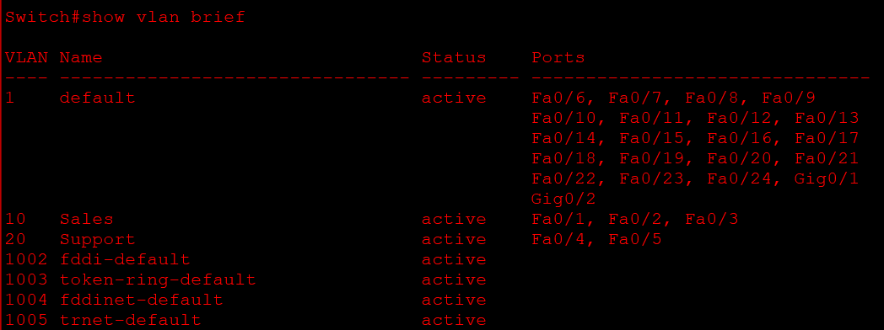
- Here’s a Log file in which I have written all the command

Q3. Connect two routers using a serial or Ethernet link in your simulation tool, assign IP addresses to their interfaces, and configure a static route on Router 1 to reach the LAN behind Router 2.
Ans. I have attached a cisco file in which I have completed the above task
Q4. Simulate a scenario where a device in the 'Sales' VLAN tries to ping a device in the 'Support' VLAN and explain why the ping fails, then suggest what configuration would allow inter-VLAN communication. Hint: Think about router-on-a-stick or Layer 3 switch concepts.
Ans. Suppose:
- Sales VLAN 10: PC1 → 192.168.10.10
- Support VLAN 20: PC2 → 192.168.20.10
PC1 tries to ping: 192.168.20.10
Why does the ping fail?
The ping fails because VLAN 10 and VLAN 20 are separate broadcast domains. A normal Layer 2 switch does not route traffic between different VLANs.
How to allow communication?
Use Router-on-a-Stick. Configure one router interface with subinterfaces:
- Router(config)# interface Fa0/0.10
- Router(config-if)# encapsulation dot1Q 10
- Router(config-if)# ip address 192.168.10.1 255.255.255.0

- Router(config)# interface Fa0/0.20
- Router(config-if)# encapsulation dot1Q 20
- Router(config-if)# ip address 192.168.20.1 255.255.255.0
The switch port connected to the router must be configured as a trunk.
Then:
- Sales PC default gateway → 192.168.10.1
- Support PC default gateway → 192.168.20.1
- Now the router can route traffic between VLAN 10 and VLAN 20, so the ping can succeed.

